JOSHUA 7 ABC 13 SEPTEMBER 2020
How to strengthen Faith in God?
No quick solution
Read His Word
Remember His Word
Live according to the revelation of His Word
Maturity takes time

Our design in these articles has been to supply something more than a bare exposition of the book of Joshua, namely to point out some of the bearings which its contents have upon us today. A true understanding of God's Word is indeed of first importance, for unless its meaning be rightly apprehended, of what service will it be unto us? Yet it is the use to which we put it, the measure in which we appropriate its principles and precepts to the regulating of our daily walk, that is equally important. "If you know these things, happy are you if you do them" (John 13:17), that is the test. Thus, to spare no pains in endeavoring to arrive at the meaning of God's Word, that he may give a sound interpretation of the same, is only a part of the duty resting upon the minister of the Gospel, and especially the teacher of God's people.
Another part of his work, equally necessary and exacting, is for him to make practical application unto his hearers of each passage he takes up, to point out the various lessons it inculcates, to accommodate it unto the present condition and circumstances of those to whom he ministers. Only so will he emulate the example left him by the Divine Teacher of the Church: only so will he pursue the same course that was followed by His apostles: only so will he be of greatest service unto His needy, tried and often sorely perplexed people. It is not the elucidation of mysteries or light upon prophecy that they most need, but that which will comfort, strengthen and stimulate them.
Arthur Pink
The Northern Campaign (Joshua 11:1-15)
The Summary of Conquests (Joshua 11:16-12:24)

Introduction
- Review of military campaigns: Jericho, Ai and Southern conquest.
- Victory is by the Lord’s hand: in spectacular and the mundane
- Joshua’s courage, skills, diligence and faith – undeniable but the book does not magnify it. From the beginning to the end, the focus is in the LORD.

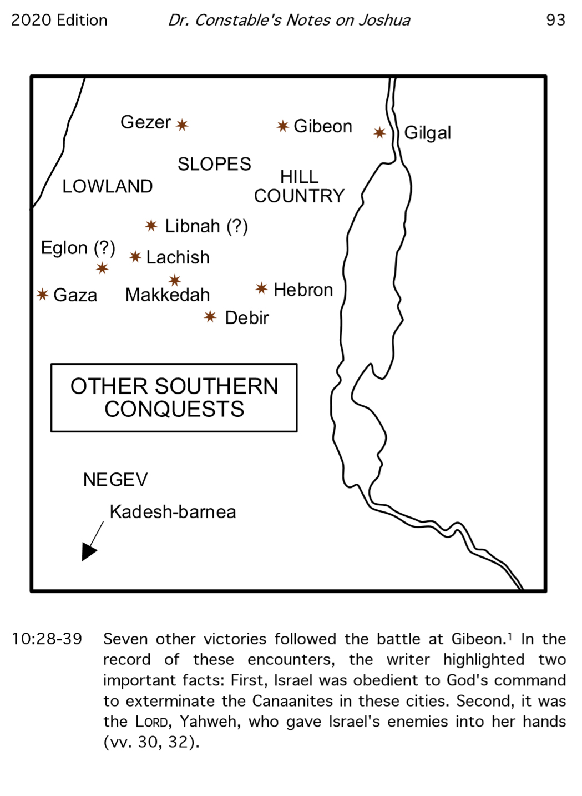

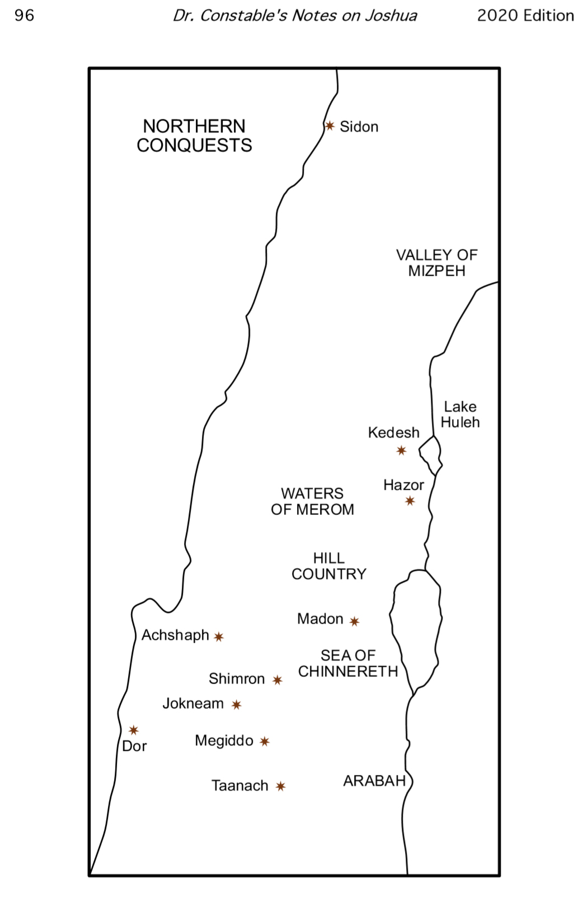

It is true that "faith comes by hearing, and hearing by the word of God" (Rom 10:11), yet it is also a fact that "The hearing ear, and the seeing eye, the Lord has made even both of them" (Pro 20:12). True alike both naturally and spiritually, for morally man is both deaf and blind to the things of God (Mat 13:13-14), and therefore the voice of mercy is disregarded and the sinner perceives no beauty in Christ that he should desire Him. To his need and to the remedy he is alike insensible. Until a miracle of grace is wrought within him, his imagination is darkened and his heart closed against God. That is why multitudes that hear the Gospel with the outward ear profit not, and those who are saved under it and receive it into their hearts do so solely because God has made them to differ from their unbelieving fellows. Jabin "had heard" of the destruction of Jericho and Ai, but instead of trembling thereat he hardened his heart. Thus do sinners rush madly to destruction, notwithstanding the repeated warnings they receive from the deaths of their godless fellows.
Arthur Pink
A real challenge was now made to Israel's further occupancy of the land, and a most terrifying sight must it have presented to the natural eye. This vast assembly was not only far more numerous than any force which Israel had previously encountered, but it was much more formidable and powerful, being provided with a great number of horses and chariots, whereas Israel's army was on foot.
Arthur Pink
18. ….Now the number of the whole army was three hundred thousand armed footmen, and ten thousand horsemen, and twenty thousand chariots; so that the multitude of the enemies affrighted both Joshua himself and the Israelites; and they, instead of being full of hopes of good success, were superstitiously timorous, with the great terror with which they were stricken. Whereupon God upbraided them with the fear they were in, and asked them whether they desired a greater help than he could afford them; and promised them that they should overcome their enemies; and withal charged them to make their enemies' horses useless, and to burn their chariots. So Joshua became full of courage upon these promises of God, and went out suddenly against the enemies; and after five days' march he came upon them, and joined battle with them, and there was a terrible fight, and such a number were slain as could not be believed by those that heard it. He also went on in the pursuit a great way, and destroyed the entire army of the enemies, few only excepted, and all the kings fell in the battle; insomuch, that when there wanted men to be killed, Joshua slew their horses, and burnt their chariots and passed all over their country without opposition, no one daring to meet him in battle; but he still went on, taking their cities by siege, and again killing whatever he took.
Josephus, Antiquities of the Jews, Book 5. Chapter 1, Para 18
A Mighty Fortress Is Our God
Did we in our own strength confide, our striving would be losing,
Were not the right Man on our side, the Man of God’s own choosing:
Dost ask who that may be? Christ Jesus, it is He;
Lord Sabaoth, His Name, from age to age the same,
And He must win the battle.
Martin Luther

The phrase "They left no one who breathed" (v. 14) has sounded to some readers like excessive punishment. However, God had clearly commanded Moses and Joshua to completely annihilate the Canaanites (v. 15). The Bible justified this severe treatment on several counts.
First, the gross sins of the Canaanites—including incest, adultery, child sacrifice, homosexuality, and bestiality— resulted in a thoroughly debased society in Canaan (cf. Lev. 18; Deut. 9:4-5). God had waited to execute judgment, allowing the Canaanites time to turn from their wicked ways, but they had not changed (cf. Gen. 15:16). By Joshua's time, their sins, which had permeated their whole culture, deserved judgment.
Second, by wiping out the Canaanites, God was protecting His people, the Israelites, from those sins.
Third, God had promised to bless those nations that blessed Israel, and to curse those nations that cursed Israel (Gen. 12:3). The Canaanites had sought to destroy the Israelites on at least two occasions, already (9:1-2; 11:1-5), and God would not permit that.
Fourth, God's command to annihilate the Canaanites was very focused; the Israelites did not ever have a mandate to kill everyone living in all of Canaan. It was only the Canaanites, at this time in history, who were the objects of God's special judgment, and the Israelites were His instrument to bring about that judgment.
Thomas Constable

For, in their former battles, he had only exercised them by a kind of pleasing preludes. It may be added, that the Lord had, by several victories, ever and anon borne testimony to his power, that they might not think more lightly of it than was meet. Had all their enemies been routed at once, they might, indeed, have magnificently celebrated the praises of God, but they might also have easily lost the remembrance of them. It was necessary, therefore, that repeated proofs distinct and apart from each other, should be held forth to their view, lest they might attribute one victory to a stroke of fortune.
John Calvin
CONCLUSION
The northern coalition was Israel’s most formidable foe in terms of both numbers and weaponry. Each successive battle that Israel fought was more difficult than the last.
Why?
Reminded of our weakness
Drawn into greater dependence on the Lord
Humbled for greater service
Assured that the Lord never abandon us
Building our character

APPLICATION
Similarly, we are in the same battle as a Christian today.
Occupying Canaan is a long drawn process.
Victory is certain but we have to work at it.
The rest in Canaan is a type of the rest we have in the future at the second coming of Jesus Christ.

